Name: Jelena Rajović
E-mail: gvozdena2001@yahoo.com
Institution: Technical College of Applied Sciences Urosevac with temporary seat in Leposavic
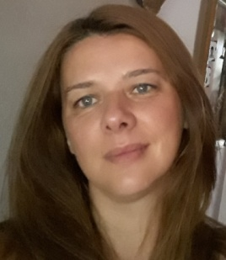 | Education: MA in English language and literature.  Position: Lecturer at Technical College of Applied Sciences Urosevac with temporary seat in Leposavic.  Organizations skills: Project management skills gained working in non-governmental organizations 1999-2006. Other leadership skills working in team and project work in cooperation with the management with other associations. Able to work under pressure and on short notice. Able to work and cooperate with people no matter on their national and religious background. Reliable, hardworking and punctual.
References (max. 5 relevant references)
1. Todorović, A., Grgur, B., Rajović J. (2010). Influence of current and temperature on discharge characteristics of electrochemical nickel-cadmium system, Chemical Industry, vol. 64, br. 4, 319-335. UDK. 621.8.001. (IF 0.137) (M23).
2. Rajović, J. (2018) Motivacija i učenje stranih jezika, Zbornik radova Međunarodnog naučnog skupa " Nauka bez granica", Filozofski fakultet Univerziteta u Prištini sa privremenim sedištem u Kosovskoj Mitrovici, Vol 5. Budućnost bez granica str. 21-33, 378.147::811.111; 159.947.5.072-057.875. (M13).
3. Vuković, M, Rajović, J, Bilafer, I, (2018), Pojmovno i teorijsko određenje prevođenja posmatrano kroz proces globalizacije jezika, Zbornik radova Medjunarodnog simpozijuma Strateški razvoj saobraćaja jugoistočne evrope, Akademija znanja, Budva 2018, str. 229-234. (M33).
4. Elezović, N. Rajović, J. S. Zlatković, S. Jovanić, P, (2017) , Risk analysis in the application of remediation technologies in treatment of sediment on Bovan reservoir, 6th International Symposium Mining and Environmental Protection, Belgrade University, Faculty of mining and geology, pp. 267 - 273, isbn: 978-86-7352-298-2, Врдник, 21. - 24. Jun,.
5. J. Rajović, N. Marković, D. Jakšić, (2017) Modern technologies in foreign languages teaching, Session 2-Informatics and Mathematics Mechanical Engineering, paper 2.25, ISBN 978-86-83573-43-1, High business-technical school of Uzice, Serbia, SED 2017, 10th International Conference, Science and higher education in function of sustainable development 6-7. October 2017, Uzice, Serbia. (M34).
This project has been funded with support from the European Commission. This publication reflects the views only of the author, and the Commission cannot be held responsible for any use which may be made of the information contained therein.

